**What you can currently do**

First, let’s install the version we used for this post:

Our ultimate goal is to submit a pull request that enables UpSetR users to specify a color by row for the dots instead of the actual rows. We had already identified an example that we could work with.

library('UpSetR')

movies <- read.csv( system.file("extdata", "movies.csv", package = "UpSetR"),

header=T, sep=";" )

require(ggplot2); require(plyr); require(gridExtra); require(grid);

## Loading required package: ggplot2

## Loading required package: plyr

## Loading required package: gridExtra

## Loading required package: grid

upset(movies,

sets = c("Action", "Comedy", "Drama"),

order.by="degree", matrix.color="blue", point.size=5,

sets.bar.color=c("maroon","blue","orange"))

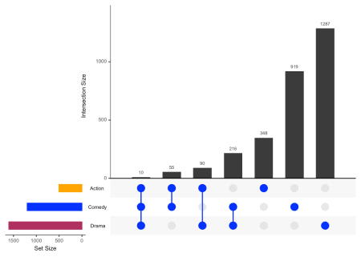

Set Metadata Vignette

For all examples the movies data set contained in the package will be used.

**library**(UpSetR)

movies <- read.csv(system.file("extdata", "movies.csv", package = "UpSetR"),

header = T, sep = ";")

*set.metadata* Parameter Breakdown

The set.metadata parameter is broken up into 3 fields: data, ncols, and plots.

* data: takes a data frame where the first column is the set names, and the following columns are attributes of the sets.
* plots: is a list that takes a list of parameters that are used to generate the plots. These parameters include column, type, assign, and colors.
* column: is the column of the dataframe that should be used for the specified plot.
* type: is what type of plot should be used to display the data from the specified column. If the data in the column is numeric, then the plot type can be either a bar plot ("hist"), or heat map ("heat"). If the data in the column is boolean, then the plot type can be a "bool" heat map. If the data in the column is categorical (character), then the plot type can either be a heat map ("heat") or text ("text"). Additionally, if the data in the column is ordinal (factor), then the plot type can be either a heat map or text. There is also a type called "matrix_rows" which allows us to use apply colors to the matrix background using categorical data. This type is useful for identifying characteristics of sets using the matrix.
* assign: is the number of the columns that should be assigned to the specific plot. For instance if you’re plotting 2 set metadata plots then you may choose one plot to take up 20 columns and other plot 10 columns. Since the UpSet plot is typically plotted on a 100 by 100 grid, the grid will now be 100 by 130 where roughly 1/4 ofthe plot is assigned to the metadata plots.
* colors: is used to specify the colors used in the metadata plots. If the plot type is a bar plot then the parameter only takes one color for the whole plot. If the plot type is "heat" or "bool", then a vector of colors can be provided where there is one color for each unique category (character). However, if the data type is ordinal (factor) there is no colors input and the heat map works on a color gradient rather than applying different colors to each level. Lastly, if the plot type is “text" then a vector of colors can be provided where there is one color for each unique string. If not colors are provided, a color palette will be provided for you.

Example 1: Set Metadata Bar Plot

In this example, the average Rotten Tomatoes movie ratings for each set will be used as the set metadata. This may help us draw more conclusions from the visualization by knowing how professional movie reviewers typically rate movies in these categories.

sets <- names(movies[3:19])

avgRottenTomatoesScore <- round(runif(17, min = 0, max = 90))

metadata <- as.data.frame(cbind(sets, avgRottenTomatoesScore))

names(metadata) <- c("sets", "avgRottenTomatoesScore")

When generating a bar plot using set metadata information it is important to make sure the specified column is numeric.

is.numeric(metadata$avgRottenTomatoesScore)

## [1] FALSE

The column is not numeric! In fact it is a factor, so we must coerce it to characters and then to integers.

metadata$avgRottenTomatoesScore <- as.numeric(as.character(metadata$avgRottenTomatoesScore))

upset(movies, set.metadata = list(data = metadata, plots = list(list(type = "hist",

column = "avgRottenTomatoesScore", assign = 20))))

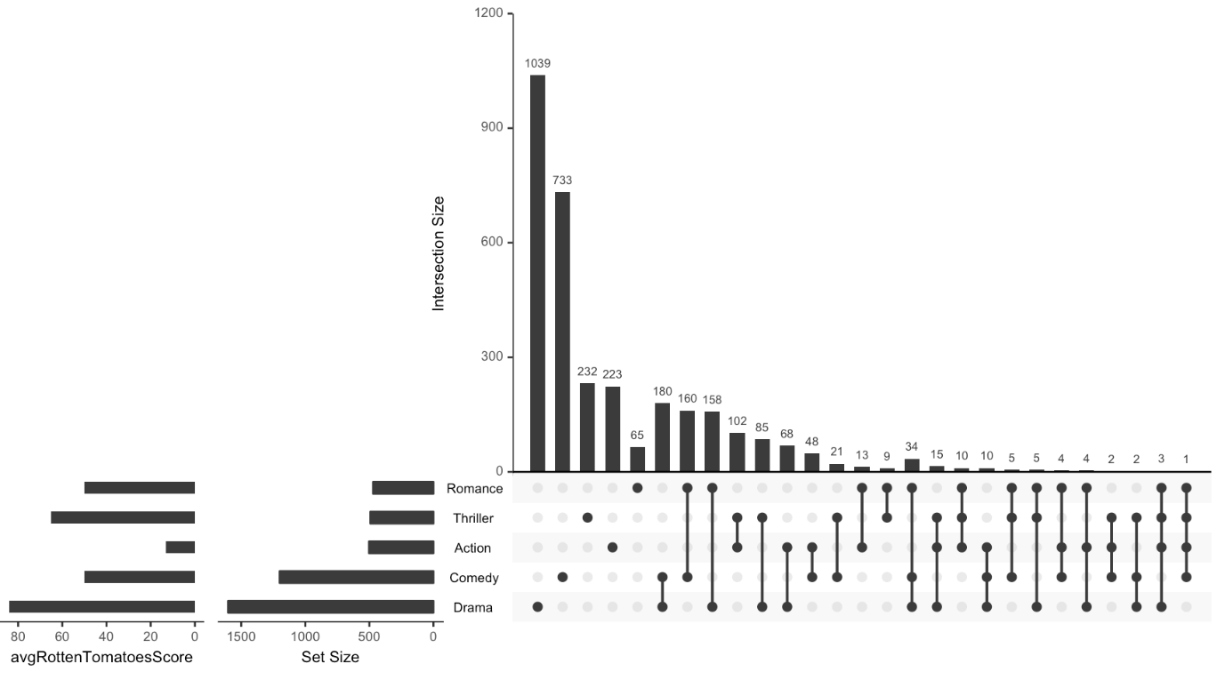

Example 2: Set Metadata Heat Map

In this example we will make our own data on what major cities these genres were most popular in. Since this is categorical and not ordinal we must remember to change the column to characters (it is a factor again). To make sure we assign specific colors to each category you can specify the name of each category in the color vector, as shown below. If you don’t care what color is assigned to each category then you don’t have to specify the category names in the color vector. R will just apply the colors to each category in the order they occur. Additionally, if you don’t supply anything for the colors parameter a default color palette will be provided for you.

Cities <- sample(c("Boston", "NYC", "LA"), 17, replace = T)

metadata <- cbind(metadata, Cities)

metadata$Cities <- as.character(metadata$Cities)

metadata[which(metadata$sets %**in**% c("Drama", "Comedy", "Action", "Thriller",

"Romance")), ]

## sets avgRottenTomatoesScore Cities

## 1 Action 13 NYC

## 4 Comedy 50 Boston

## 7 Drama 84 NYC

## 13 Romance 50 Boston

## 15 Thriller 65 NYC

upset(movies, set.metadata = list(data = metadata, plots = list(list(type = "heat",

column = "Cities", assign = 10, colors = c(Boston = "green", NYC = "navy",

LA = "purple")))))

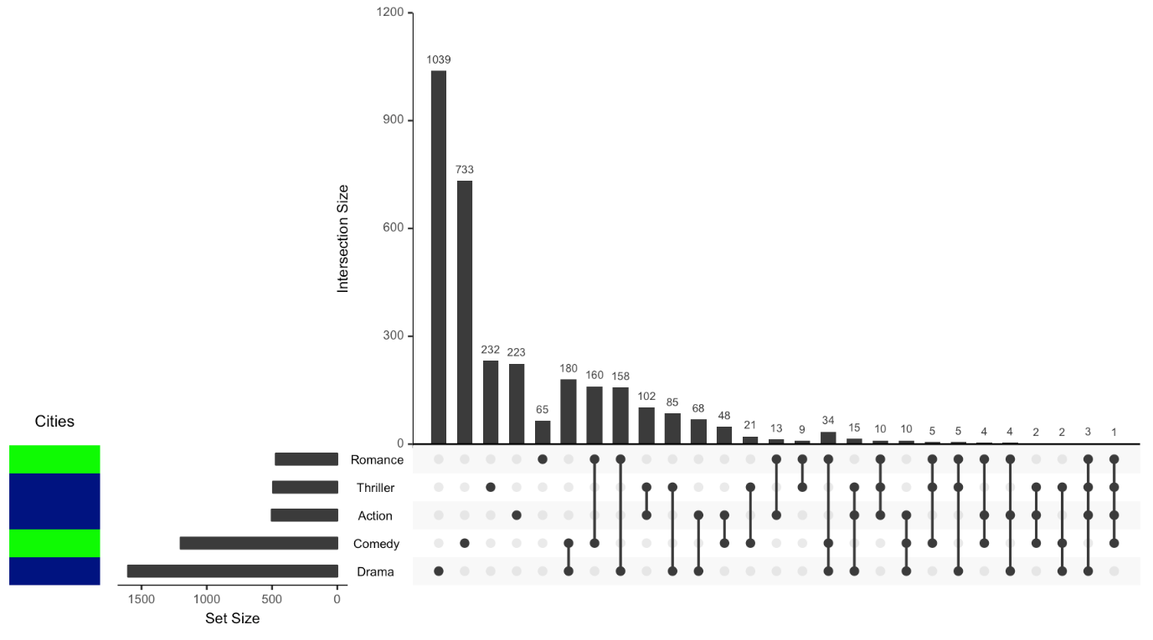

Now lets also use our numeric critic values!

upset(movies, set.metadata = list(data = metadata, plots = list(list(type = "heat",

column = "Cities", assign = 10, colors = c(Boston = "green", NYC = "navy",

LA = "purple")), list(type = "heat", column = "avgRottenTomatoesScore",

assign = 10))))

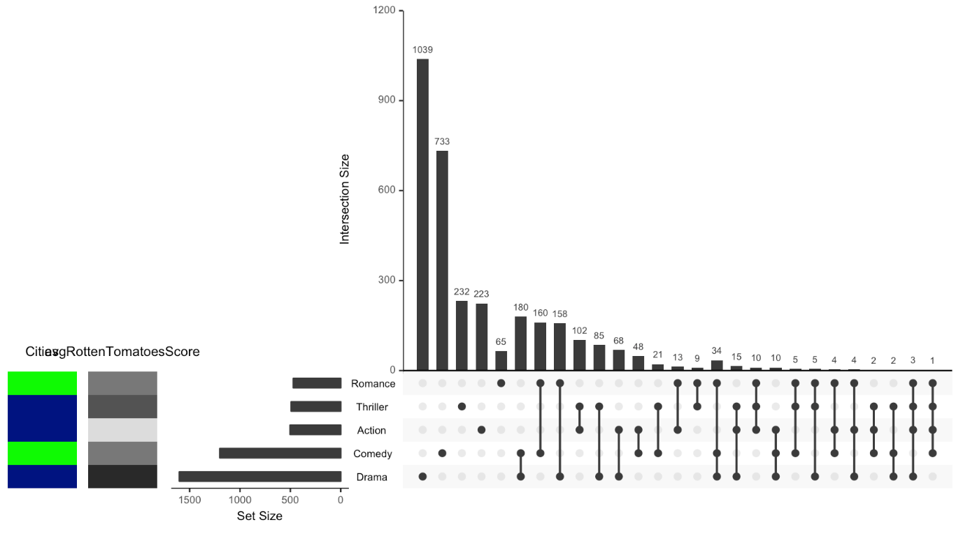

As a side note, the way the numerical heat map is handled is similar to how the ordinal heat maps are handled.

Example 3: Set Metadata Boolean Heat Map

Now suppose we have metadata that tells us whether or not these genres are well accepted overseas. This could be used as a categorical column where there are only two categories, but for this example we will assume that your data is coded in 1’s and 0’s. It is important to keep in mind that if you run a “heat” with 0’s and 1’s instead of a “bool” the binary data will be treated as numerical values, and a color gradient will be used to show the relative differences.

accepted <- round(runif(17, min = 0, max = 1))

metadata <- cbind(metadata, accepted)

metadata[which(metadata$sets %**in**% c("Drama", "Comedy", "Action", "Thriller",

"Romance")), ]

## sets avgRottenTomatoesScore Cities accepted

## 1 Action 13 NYC 1

## 4 Comedy 50 Boston 0

## 7 Drama 84 NYC 0

## 13 Romance 50 Boston 0

## 15 Thriller 65 NYC 1

upset(movies, set.metadata = list(data = metadata, plots = list(list(type = "bool",

column = "accepted", assign = 5, colors = c("#FF3333", "#006400")))))

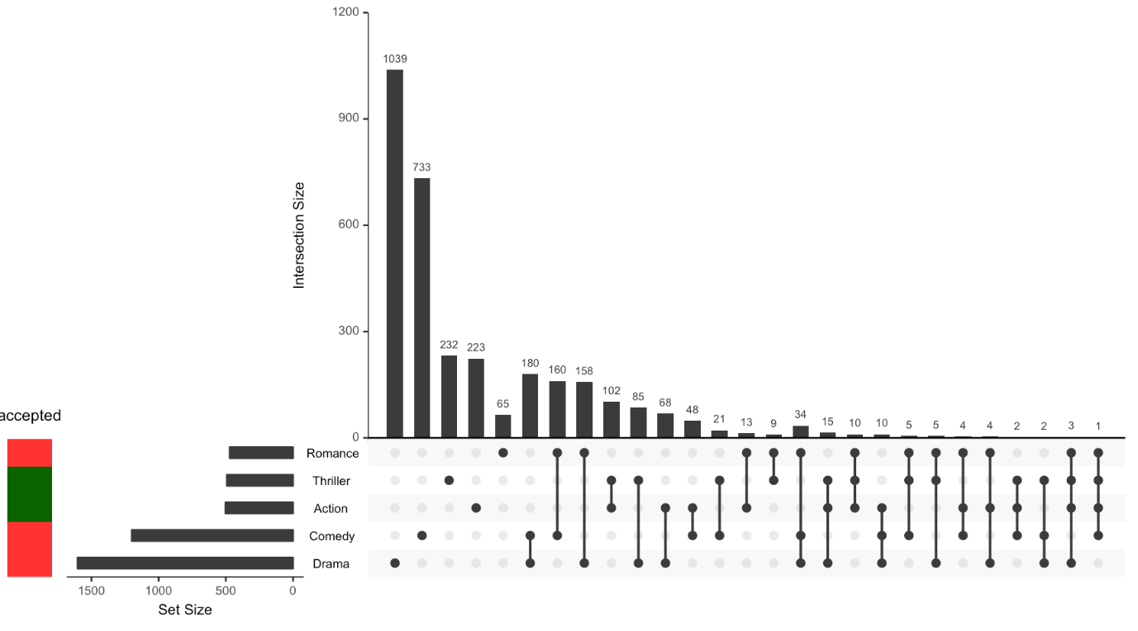

Let’s see what happens when we choose a “heat” instead of a “bool” for our binary data column.

upset(movies, set.metadata = list(data = metadata, plots = list(list(type = "heat",

column = "accepted", assign = 5, colors = c("red", "green")))))

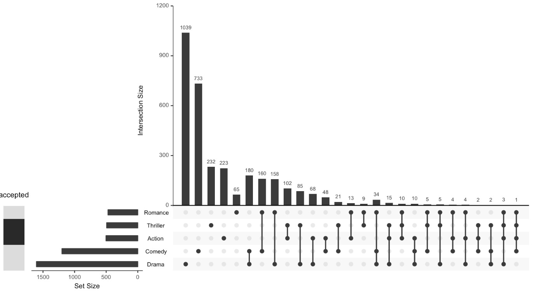

Example 4: Set Metadata Text

Lets say we prefer to show text instead of a heat map for the cities these genres were most popular in.

upset(movies, set.metadata = list(data = metadata, plots = list(list(type = "text",

column = "Cities", assign = 10, colors = c(Boston = "green", NYC = "navy",

LA = "purple")))))

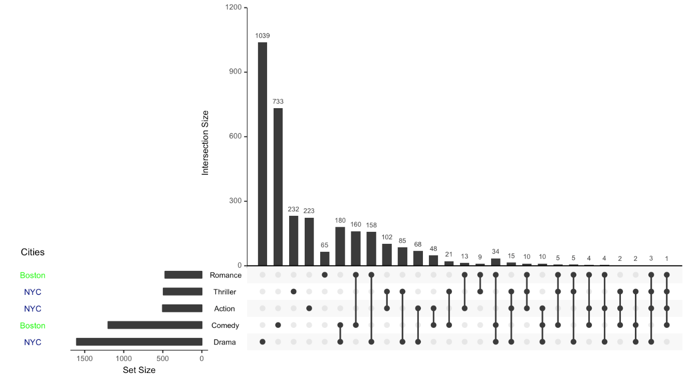

Example 5: Applying Metadata to the Matrix

In some cases we may just want to incorporate categorical set metadata directly into the UpSet plot to easily identify characteristics of the sets via the matrix. To do this we need to specify the type as "matrix_rows", what column we’re using to categorize the sets, and the colors to apply to each category. There is also an option to change the opacity of the matrix background using alpha. To change the opacity of the matrix background without applying set metadata see the shade.alpha parameter in the upset() function documentation.

upset(movies, set.metadata = list(data = metadata, plots = list(list(type = "hist",

column = "avgRottenTomatoesScore", assign = 20), list(type = "matrix_rows",

column = "Cities", colors = c(Boston = "green", NYC = "navy", LA = "purple"),

alpha = 0.5))))

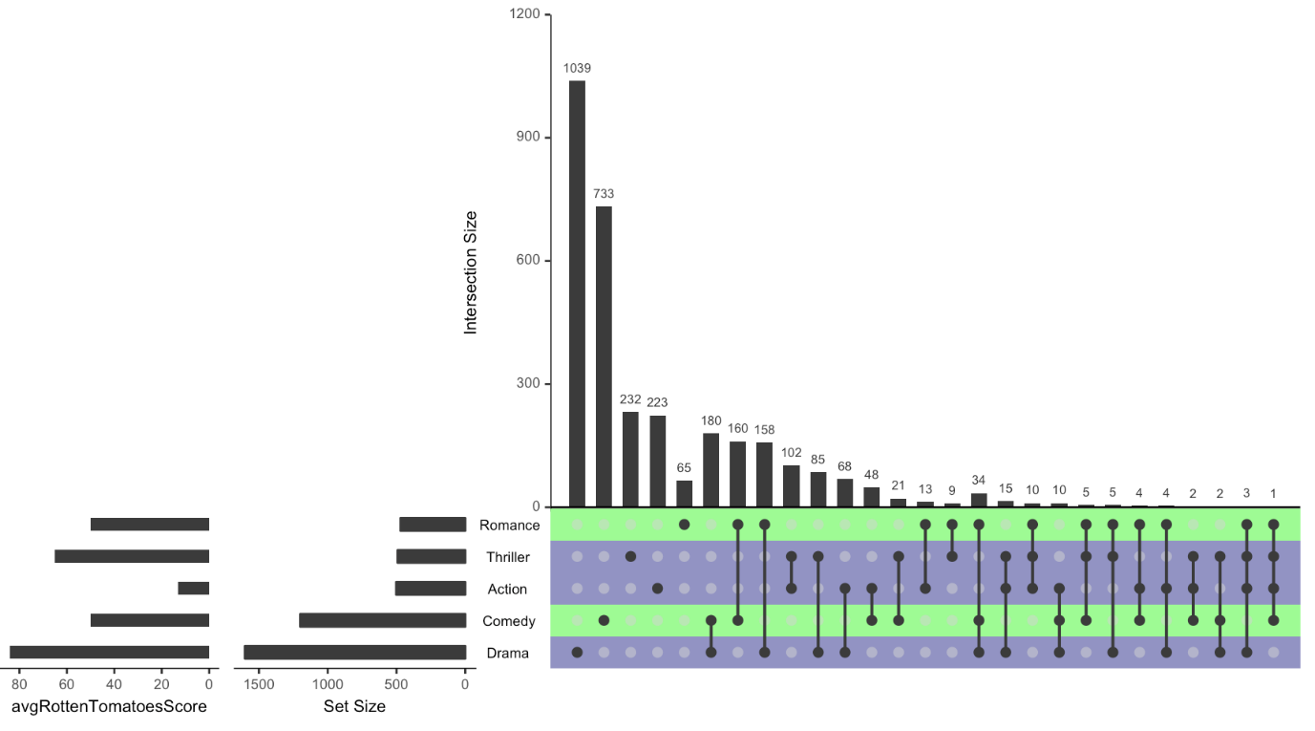

Example 6: Multiple Metadata Plots At Once

Now lets sum up all of our metadata information together on one plot!

upset(movies, set.metadata = list(data = metadata, plots = list(list(type = "hist",

column = "avgRottenTomatoesScore", assign = 20), list(type = "bool", column = "accepted",

assign = 5, colors = c("#FF3333", "#006400")), list(type = "text", column = "Cities",

assign = 5, colors = c(Boston = "green", NYC = "navy", LA = "purple")))))

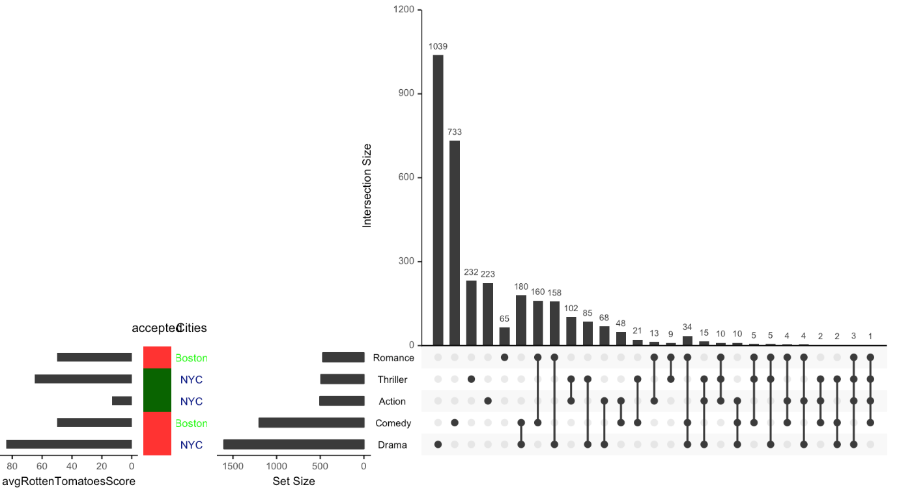

Example 7: Metadata Plots, Queries, and Attribute Plots

Finally, lets include functionalities discussed in all of the other UpSetR Vignettes! This gives us a very in depth look at information about our sets, intersections, and specific elements.

upset(movies, set.metadata = list(data = metadata, plots = list(list(type = "hist",

column = "avgRottenTomatoesScore", assign = 20), list(type = "bool", column = "accepted",

assign = 5, colors = c("#FF3333", "#006400")), list(type = "text", column = "Cities",

assign = 5, colors = c(Boston = "green", NYC = "navy", LA = "purple")),

list(type = "matrix_rows", column = "Cities", colors = c(Boston = "green",

NYC = "navy", LA = "purple"), alpha = 0.5))), queries = list(list(query = intersects,

params = list("Drama"), color = "red", active = F), list(query = intersects,

params = list("Action", "Drama"), active = T), list(query = intersects,

params = list("Drama", "Comedy", "Action"), color = "orange", active = T)),

attribute.plots = list(gridrows = 45, plots = list(list(plot = scatter_plot,

x = "ReleaseDate", y = "AvgRating", queries = T), list(plot = scatter_plot,

x = "AvgRating", y = "Watches", queries = F)), ncols = 2), query.legend = "bottom")

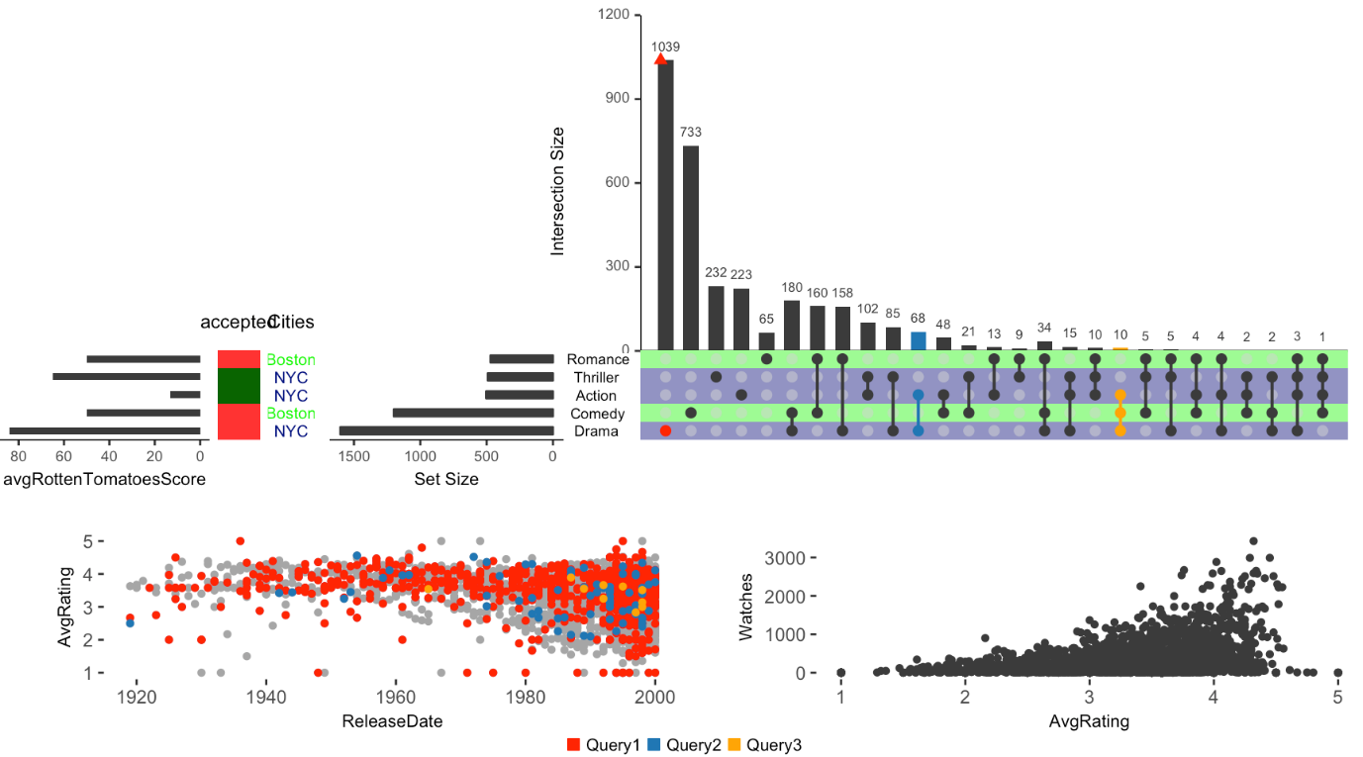

We also explored the set metadata vignette that includes examples such as the following one.

set.seed(20180727)

## Create the metadata object first

sets <- names(movies[3:19])

avgRottenTomatoesScore <- round(runif(17, min = 0, max = 90))

metadata <- as.data.frame(cbind(sets, avgRottenTomatoesScore))

names(metadata) <- c("sets", "avgRottenTomatoesScore")

metadata$avgRottenTomatoesScore <- as.numeric(as.character(metadata$avgRottenTomatoesScore))

Cities <- sample(c("Boston", "NYC", "LA"), 17, replace = T)

metadata <- cbind(metadata, Cities)

metadata$Cities <- as.character(metadata$Cities)

metadata[which(metadata$sets %in% c("Drama", "Comedy", "Action", "Thriller",

"Romance")), ]

## sets avgRottenTomatoesScore Cities

## 1 Action 68 Boston

## 4 Comedy 40 NYC

## 7 Drama 48 LA

## 13 Romance 77 Boston

## 15 Thriller 19 NYC

accepted <- round(runif(17, min = 0, max = 1))

metadata <- cbind(metadata, accepted)

metadata[which(metadata$sets %in% c("Drama", "Comedy", "Action", "Thriller",

"Romance")), ]

## sets avgRottenTomatoesScore Cities accepted

## 1 Action 68 Boston 0

## 4 Comedy 40 NYC 1

## 7 Drama 48 LA 0

## 13 Romance 77 Boston 1

## 15 Thriller 19 NYC 0

## Now make the plot

upset(movies, set.metadata = list(data = metadata, plots = list(list(type = "hist",

column = "avgRottenTomatoesScore", assign = 20), list(type = "matrix_rows",

column = "Cities", colors = c(Boston = "green", NYC = "navy", LA = "purple"),

alpha = 0.5))))

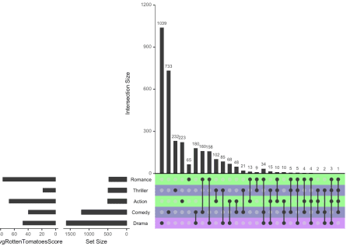

**Hacking our way**

Using the metadata looked complicated to us and hopefully not necessary for what we are trying to accomplish. That is, we really wanted to change the colors of the circles in each row, not the rows themselves.. We went the rabbit hole to see how the matrix.color argument got used. To actually hack our way through, we downloaded the latest version of the code using git.

git clone git@github.com:hms-dbmi/UpSetR.git

cd UpSetR

Next, we created the objects that match the default arguments of upset() by finding and replacing commas by semi-colons. Well, not all of the commas. Also, for inputs that specified a vector (mostly 2 options), we chose the first one to match the default R behavior. This way we could execute them and have them in our session.

## Default upset() arguments

nsets = 5; nintersects = 40; sets = NULL; keep.order = F; set.metadata = NULL; intersections = NULL;

matrix.color = "gray23"; main.bar.color = "gray23"; mainbar.y.label = "Intersection Size"; mainbar.y.max = NULL;

sets.bar.color = "gray23"; sets.x.label = "Set Size"; point.size = 2.2; line.size = 0.7;

mb.ratio = c(0.70,0.30); expression = NULL; att.pos = NULL; att.color = main.bar.color; order.by = 'freq';

decreasing = T; show.numbers = "yes"; number.angles = 0; group.by = "degree";cutoff = NULL;

queries = NULL; query.legend = "none"; shade.color = "gray88"; shade.alpha = 0.25; matrix.dot.alpha =0.5;

empty.intersections = NULL; color.pal = 1; boxplot.summary = NULL; attribute.plots = NULL; scale.intersections = "identity";

scale.sets = "identity"; text.scale = 1; set_size.angles = 0 ; set_size.show = FALSE

Next, we did the same (commas to semicolons) for the inputs of the first example.

## Initial inputs on the first example

movies <- read.csv( system.file("extdata", "movies.csv", package = "UpSetR"),

header=T, sep=";" )

## comma -> semicolon

data = movies; sets = c("Action", "Comedy", "Drama");

order.by="degree"; matrix.color="blue"; point.size=5;

sets.bar.color=c("maroon","blue","orange")

**Hacking internals**

The function upset() is pretty long and uses many un-exported functions from the package itself. In order to test thing quickly we added UpSetR::: calls before the un-exported functions. Here’s our modified version where we added a piece of code to modify the Matrix_layout object and add some colors.

Library(UpsetR)

## Piece of code we introduced

for(i in 1:3) {

j <- which(Matrix_layout$y == i & Matrix_layout$value == 1)

if(length(j) > 0) Matrix_layout$color[j] <- c("maroon","blue","orange")[i]

}

Ok, here’s the full modified upset() function.

## Modified internal upset() code

startend <- UpSetR:::FindStartEnd(data)

first.col <- startend[1]

last.col <- startend[2]

if(color.pal == 1){

palette <- c("#1F77B4", "#FF7F0E", "#2CA02C", "#D62728", "#9467BD", "#8C564B", "#E377C2",

"#7F7F7F", "#BCBD22", "#17BECF")

} else{

palette <- c("#E69F00", "#56B4E9", "#009E73", "#F0E442", "#0072B2", "#D55E00",

"#CC79A7")

}

if(is.null(intersections) == F){

Set_names <- unique((unlist(intersections)))

Sets_to_remove <- UpSetR:::Remove(data, first.col, last.col, Set_names)

New_data <- UpSetR:::Wanted(data, Sets_to_remove)

Num_of_set <- UpSetR:::Number_of_sets(Set_names)

if(keep.order == F){

Set_names <- UpSetR:::order_sets(New_data, Set_names)

}

All_Freqs <- UpSetR:::specific_intersections(data, first.col, last.col, intersections, order.by, group.by, decreasing,

cutoff, main.bar.color, Set_names)

} else if(is.null(intersections) == T){

Set_names <- sets

if(is.null(Set_names) == T || length(Set_names) == 0 ){

Set_names <- UpSetR:::FindMostFreq(data, first.col, last.col, nsets)

}

Sets_to_remove <- UpSetR:::Remove(data, first.col, last.col, Set_names)

New_data <- UpSetR:::Wanted(data, Sets_to_remove)

Num_of_set <- UpSetR:::Number_of_sets(Set_names)

if(keep.order == F){

Set_names <- UpSetR:::order_sets(New_data, Set_names)

}

All_Freqs <- UpSetR:::Counter(New_data, Num_of_set, first.col, Set_names, nintersects, main.bar.color,

order.by, group.by, cutoff, empty.intersections, decreasing)

}

Matrix_setup <- UpSetR:::Create_matrix(All_Freqs)

labels <- UpSetR:::Make_labels(Matrix_setup)

#Chose NA to represent NULL case as result of NA being inserted when at least one contained both x and y

#i.e. if one custom plot had both x and y, and others had only x, the y's for the other plots were NA

#if I decided to make the NULL case (all x and no y, or vice versa), there would have been alot more if/else statements

#NA can be indexed so that we still get the non NA y aesthetics on correct plot. NULL cant be indexed.

att.x <- c(); att.y <- c();

if(is.null(attribute.plots) == F){

for(i in seq_along(attribute.plots$plots)){

if(length(attribute.plots$plots[[i]]$x) != 0){

att.x[i] <- attribute.plots$plots[[i]]$x

}

else if(length(attribute.plots$plots[[i]]$x) == 0){

att.x[i] <- NA

}

if(length(attribute.plots$plots[[i]]$y) != 0){

att.y[i] <- attribute.plots$plots[[i]]$y

}

else if(length(attribute.plots$plots[[i]]$y) == 0){

att.y[i] <- NA

}

}

}

BoxPlots <- NULL

if(is.null(boxplot.summary) == F){

BoxData <- UpSetR:::IntersectionBoxPlot(All_Freqs, New_data, first.col, Set_names)

BoxPlots <- list()

for(i in seq_along(boxplot.summary)){

BoxPlots[[i]] <- UpSetR:::BoxPlotsPlot(BoxData, boxplot.summary[i], att.color)

}

}

customAttDat <- NULL

customQBar <- NULL

Intersection <- NULL

Element <- NULL

legend <- NULL

EBar_data <- NULL

if(is.null(queries) == F){

custom.queries <- UpSetR:::SeperateQueries(queries, 2, palette)

customDat <- UpSetR:::customQueries(New_data, custom.queries, Set_names)

legend <- UpSetR:::GuideGenerator(queries, palette)

legend <- UpSetR:::Make_legend(legend)

if(is.null(att.x) == F && is.null(customDat) == F){

customAttDat <- UpSetR:::CustomAttData(customDat, Set_names)

}

customQBar <- UpSetR:::customQueriesBar(customDat, Set_names, All_Freqs, custom.queries)

}

if(is.null(queries) == F){

Intersection <- UpSetR:::SeperateQueries(queries, 1, palette)

Matrix_col <- UpSetR:::intersects(QuerieInterData, Intersection, New_data, first.col, Num_of_set,

All_Freqs, expression, Set_names, palette)

Element <- UpSetR:::SeperateQueries(queries, 1, palette)

EBar_data <-UpSetR:::ElemBarDat(Element, New_data, first.col, expression, Set_names,palette, All_Freqs)

} else{

Matrix_col <- NULL

}

Matrix_layout <- UpSetR:::Create_layout(Matrix_setup, matrix.color, Matrix_col, matrix.dot.alpha)

As a little pause in upset(), let’s check what actually Matrix_layout looks.

Matrix_layout

## y x value color alpha Intersection

## 1 1 1 1 blue 1.0 1yes

## 2 2 1 1 blue 1.0 1yes

## 3 3 1 1 blue 1.0 1yes

## 4 1 2 0 gray83 0.5 4No

## 5 2 2 1 blue 1.0 2yes

## 6 3 2 1 blue 1.0 2yes

## 7 1 3 1 blue 1.0 3yes

## 8 2 3 0 gray83 0.5 8No

## 9 3 3 1 blue 1.0 3yes

## 10 1 4 1 blue 1.0 4yes

## 11 2 4 1 blue 1.0 4yes

## 12 3 4 0 gray83 0.5 12No

## 13 1 5 0 gray83 0.5 13No

## 14 2 5 0 gray83 0.5 14No

## 15 3 5 1 blue 1.0 5yes

## 16 1 6 0 gray83 0.5 16No

## 17 2 6 1 blue 1.0 6yes

## 18 3 6 0 gray83 0.5 18No

## 19 1 7 1 blue 1.0 7yes

## 20 2 7 0 gray83 0.5 20No

## 21 3 7 0 gray83 0.5 21No

We figured out that we had to change the colors only the rows with value = 1 and that y was the row grouping variable.

## our modification

for(i in 1:3) {

j <- which(Matrix_layout$y == i & Matrix_layout$value == 1)

if(length(j) > 0) Matrix_layout$color[j] <- c("maroon","blue","orange")[i]

}

Here’s our modified Matrix_layout:

Matrix_layout

## y x value color alpha Intersection

## 1 1 1 1 maroon 1.0 1yes

## 2 2 1 1 blue 1.0 1yes

## 3 3 1 1 orange 1.0 1yes

## 4 1 2 0 gray83 0.5 4No

## 5 2 2 1 blue 1.0 2yes

## 6 3 2 1 orange 1.0 2yes

## 7 1 3 1 maroon 1.0 3yes

## 8 2 3 0 gray83 0.5 8No

## 9 3 3 1 orange 1.0 3yes

## 10 1 4 1 maroon 1.0 4yes

## 11 2 4 1 blue 1.0 4yes

## 12 3 4 0 gray83 0.5 12No

## 13 1 5 0 gray83 0.5 13No

## 14 2 5 0 gray83 0.5 14No

## 15 3 5 1 orange 1.0 5yes

## 16 1 6 0 gray83 0.5 16No

## 17 2 6 1 blue 1.0 6yes

## 18 3 6 0 gray83 0.5 18No

## 19 1 7 1 maroon 1.0 7yes

## 20 2 7 0 gray83 0.5 20No

## 21 3 7 0 gray83 0.5 21No

Ok, let’s continue with the rest of upset().

## continuing with upset()

Set_sizes <- UpSetR:::FindSetFreqs(New_data, first.col, Num_of_set, Set_names, keep.order)

Bar_Q <- NULL

if(is.null(queries) == F){

Bar_Q <- UpSetR:::intersects(QuerieInterBar, Intersection, New_data, first.col, Num_of_set, All_Freqs, expression, Set_names, palette)

}

QInter_att_data <- NULL

QElem_att_data <- NULL

if((is.null(queries) == F) & (is.null(att.x) == F)){

QInter_att_data <- UpSetR:::intersects(QuerieInterAtt, Intersection, New_data, first.col, Num_of_set, att.x, att.y,

expression, Set_names, palette)

QElem_att_data <- UpSetR:::elements(QuerieElemAtt, Element, New_data, first.col, expression, Set_names, att.x, att.y,

palette)

}

AllQueryData <- UpSetR:::combineQueriesData(QInter_att_data, QElem_att_data, customAttDat, att.x, att.y)

ShadingData <- NULL

if(is.null(set.metadata) == F){

ShadingData <- get_shade_groups(set.metadata, Set_names, Matrix_layout, shade.alpha)

output <- Make_set_metadata_plot(set.metadata, Set_names)

set.metadata.plots <- output[[1]]

set.metadata <- output[[2]]

if(is.null(ShadingData) == FALSE){

shade.alpha <- unique(ShadingData$alpha)

}

} else {

set.metadata.plots <- NULL

}

if(is.null(ShadingData) == TRUE){

ShadingData <- UpSetR:::MakeShading(Matrix_layout, shade.color)

}

Main_bar <- suppressMessages(UpSetR:::Make_main_bar(All_Freqs, Bar_Q, show.numbers, mb.ratio, customQBar, number.angles, EBar_data, mainbar.y.label,

mainbar.y.max, scale.intersections, text.scale, attribute.plots))

Matrix <- UpSetR:::Make_matrix_plot(Matrix_layout, Set_sizes, All_Freqs, point.size, line.size,

text.scale, labels, ShadingData, shade.alpha)

Sizes <- UpSetR:::Make_size_plot(Set_sizes, sets.bar.color, mb.ratio, sets.x.label, scale.sets, text.scale, set_size.angles,set_size.show)

# Make_base_plot(Main_bar, Matrix, Sizes, labels, mb.ratio, att.x, att.y, New_data,

# expression, att.pos, first.col, att.color, AllQueryData, attribute.plots,

# legend, query.legend, BoxPlots, Set_names, set.metadata, set.metadata.plots)

structure(class = "upset",

.Data=list(

Main_bar = Main_bar,

Matrix = Matrix,

Sizes = Sizes,

labels = labels,

mb.ratio = mb.ratio,

att.x = att.x,

att.y = att.y,

New_data = New_data,

expression = expression,

att.pos = att.pos,

first.col = first.col,

att.color = att.color,

AllQueryData = AllQueryData,

attribute.plots = attribute.plots,

legend = legend,

query.legend = query.legend,

BoxPlots = BoxPlots,

Set_names = Set_names,

set.metadata = set.metadata,

set.metadata.plots = set.metadata.plots)

)

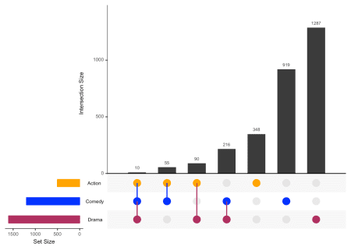

**Line colors**

Ok, that’s great but we have a problem with the lines. The color is no longer black, so we went deeper into the rabbit hole and found that the internal Make_matrix_plot() function is where the lines are made. We made some edits but got a plot where the lines were on top of the circles as shown in this screenshot.

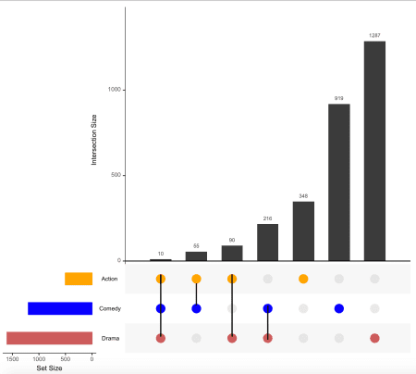

Our club session was out of time, so we decided to continue our project another day and ask for help on twitter. And yay, we got help super fast!

So here’s our modified version of Make_matrix_plot() that keeps the lines black.

Make_matrix_plot <- function(Mat_data,Set_size_data, Main_bar_data, point_size, line_size, text_scale, labels,

shading_data, shade_alpha){

if(length(text_scale) == 1){

name_size_scale <- text_scale

}

if(length(text_scale) > 1 && length(text_scale) <= 6){

name_size_scale <- text_scale[5]

}

Mat_data$line_col <- 'black'

Matrix_plot <- (ggplot()

+ theme(panel.background = element_rect(fill = "white"),

plot.margin=unit(c(-0.2,0.5,0.5,0.5), "lines"),

axis.text.x = element_blank(),

axis.ticks.x = element_blank(),

axis.ticks.y = element_blank(),

axis.text.y = element_text(colour = "gray0",

size = 7*name_size_scale, hjust = 0.4),

panel.grid.major = element_blank(),

panel.grid.minor = element_blank())

+ xlab(NULL) + ylab(" ")

+ scale_y_continuous(breaks = c(1:nrow(Set_size_data)),

limits = c(0.5,(nrow(Set_size_data) +0.5)),

labels = labels, expand = c(0,0))

+ scale_x_continuous(limits = c(0,(nrow(Main_bar_data)+1 )), expand = c(0,0))

+ geom_rect(data = shading_data, aes_string(xmin = "min", xmax = "max",

ymin = "y_min", ymax = "y_max"),

fill = shading_data$shade_color, alpha = shade_alpha)

+ geom_line(data= Mat_data, aes_string(group = "Intersection", x="x", y="y",

colour = "line_col"), size = line_size)

+ geom_point(data= Mat_data, aes_string(x= "x", y= "y"), colour = Mat_data$color,

size= point_size, alpha = Mat_data$alpha, shape=16)

+ scale_color_identity())

Matrix_plot <- ggplot_gtable(ggplot_build(Matrix_plot))

return(Matrix_plot)

}

Using that modified version we can then run the code again (note that we are not using UpSetR::: before Make_matrix_plot) and get the plot we wanted.

Matrix <- Make_matrix_plot(Matrix_layout, Set_sizes, All_Freqs, point.size, line.size,

text.scale, labels, ShadingData, shade.alpha)

Sizes <- UpSetR:::Make_size_plot(Set_sizes, sets.bar.color, mb.ratio, sets.x.label, scale.sets, text.scale, set_size.angles,set_size.show)

# Make_base_plot(Main_bar, Matrix, Sizes, labels, mb.ratio, att.x, att.y, New_data,

# expression, att.pos, first.col, att.color, AllQueryData, attribute.plots,

# legend, query.legend, BoxPlots, Set_names, set.metadata, set.metadata.plots)

structure(class = "upset",

.Data=list(

Main_bar = Main_bar,

Matrix = Matrix,

Sizes = Sizes,

labels = labels,

mb.ratio = mb.ratio,

att.x = att.x,

att.y = att.y,

New_data = New_data,

expression = expression,

att.pos = att.pos,

first.col = first.col,

att.color = att.color,

AllQueryData = AllQueryData,

attribute.plots = attribute.plots,

legend = legend,

query.legend = query.legend,

BoxPlots = BoxPlots,

Set_names = Set_names,

set.metadata = set.metadata,

set.metadata.plots = set.metadata.plots)

)

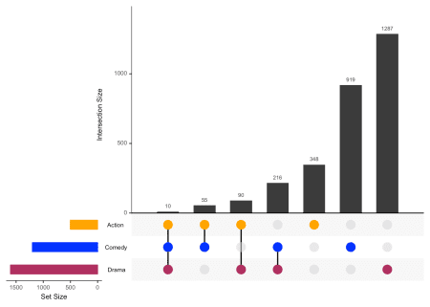

**Reproducibility**

## Session info ----------------------------------------------------------------------------------------------------------

## setting value

## version R version 3.5.1 (2018-07-02)

## system x86_64, darwin15.6.0

## ui X11

## language (EN)

## collate en_US.UTF-8

## tz America/New_York

## date 2018-07-27

## Packages --------------------------------------------------------------------------------------------------------------

## package * version date source

## assertthat 0.2.0 2017-04-11 cran (@0.2.0)

## backports 1.1.2 2017-12-13 cran (@1.1.2)

## base * 3.5.1 2018-07-05 local

## bibtex 0.4.2 2017-06-30 CRAN (R 3.5.0)

## bindr 0.1.1 2018-03-13 cran (@0.1.1)

## bindrcpp 0.2.2 2018-03-29 cran (@0.2.2)

## BiocStyle * 2.8.2 2018-05-30 Bioconductor

## blogdown 0.8 2018-07-15 CRAN (R 3.5.0)

## bookdown 0.7 2018-02-18 CRAN (R 3.5.0)

## colorout * 1.2-0 2018-05-03 Github (jalvesaq/colorout@c42088d)

## colorspace 1.3-2 2016-12-14 cran (@1.3-2)

## compiler 3.5.1 2018-07-05 local

## crayon 1.3.4 2017-09-16 cran (@1.3.4)

## datasets * 3.5.1 2018-07-05 local

## devtools * 1.13.6 2018-06-27 cran (@1.13.6)

## digest 0.6.15 2018-01-28 CRAN (R 3.5.0)

## dplyr 0.7.6 2018-06-29 CRAN (R 3.5.1)

## evaluate 0.11 2018-07-17 CRAN (R 3.5.0)

## ggplot2 * 3.0.0 2018-07-03 CRAN (R 3.5.0)

## glue 1.3.0 2018-07-17 CRAN (R 3.5.0)

## graphics * 3.5.1 2018-07-05 local

## grDevices * 3.5.1 2018-07-05 local

## grid * 3.5.1 2018-07-05 local

## gridExtra * 2.3 2017-09-09 CRAN (R 3.5.0)

## gtable 0.2.0 2016-02-26 CRAN (R 3.5.0)

## htmltools 0.3.6 2017-04-28 cran (@0.3.6)

## httr 1.3.1 2017-08-20 CRAN (R 3.5.0)

## jsonlite 1.5 2017-06-01 CRAN (R 3.5.0)

## knitcitations * 1.0.8 2017-07-04 CRAN (R 3.5.0)

## knitr 1.20 2018-02-20 cran (@1.20)

## labeling 0.3 2014-08-23 cran (@0.3)

## lazyeval 0.2.1 2017-10-29 CRAN (R 3.5.0)

## lubridate 1.7.4 2018-04-11 CRAN (R 3.5.0)

## magrittr 1.5 2014-11-22 cran (@1.5)

## memoise 1.1.0 2017-04-21 CRAN (R 3.5.0)

## methods * 3.5.1 2018-07-05 local

## munsell 0.5.0 2018-06-12 CRAN (R 3.5.0)

## pillar 1.3.0 2018-07-14 CRAN (R 3.5.0)

## pkgconfig 2.0.1 2017-03-21 cran (@2.0.1)

## plyr * 1.8.4 2016-06-08 cran (@1.8.4)

## purrr 0.2.5 2018-05-29 cran (@0.2.5)

## R6 2.2.2 2017-06-17 CRAN (R 3.5.0)

## Rcpp 0.12.18 2018-07-23 CRAN (R 3.5.1)

## RefManageR 1.2.0 2018-04-25 CRAN (R 3.5.0)

## rlang 0.2.1 2018-05-30 cran (@0.2.1)

## rmarkdown 1.10 2018-06-11 CRAN (R 3.5.0)

## rprojroot 1.3-2 2018-01-03 cran (@1.3-2)

## scales 0.5.0 2017-08-24 cran (@0.5.0)

## stats * 3.5.1 2018-07-05 local

## stringi 1.2.4 2018-07-20 CRAN (R 3.5.0)

## stringr 1.3.1 2018-05-10 CRAN (R 3.5.0)

## tibble 1.4.2 2018-01-22 cran (@1.4.2)

## tidyselect 0.2.4 2018-02-26 cran (@0.2.4)

## tools 3.5.1 2018-07-05 local

## UpSetR * 1.4.0 2018-07-27 Github (hms-dbmi/UpSetR@fe2812c)

## utils * 3.5.1 2018-07-05 local

## withr 2.1.2 2018-03-15 CRAN (R 3.5.0)

## xfun 0.3 2018-07-06 CRAN (R 3.5.0)

## xml2 1.2.0 2018-01-24 CRAN (R 3.5.0)

## yaml 2.1.19 2018-05-01 CRAN (R 3.5.0)

